**Part A**

**Instructions:  
1. If asked to create an iPhone app, create a separate project for that particular question.**

**2. You are not allowed to access the Internet at all. You may only use Apple documentation.**

**3. Each problem is worth 20 points.**

**4. For Q5, the table view should have two sections. Memorizing the code done in class will not help you in this assignment.**

**5. Good Luck!**

**Total marks: 150**

Q1. List some other technologies/frameworks other than Xcode, ObjectiveC and Swift that can be used to build iOS apps. [5]

**Answer:** Xamarin with C# programming language and .net framework, PhoneGap with Ionic framework, Applcelerator with JavaScript.

Q2. In a playground file, create an array of tuples that contain a String, Int and Double. Using a for in loop, iterate through this array and print out each of the tuple elements separated by the string: “~>” [5]

Q3. List the functions the implement the Application Life Cycle in no particular order. [10]

**Answer:** didFinishLaunchingWithOptions

applicationWillResignActive

applicationDidEnterBackground

applicationWillEnterForeground

applicationDidBecomeActive

applicationWillTerminate

**Or**

Difference between ARC and MRC. [10]

Q4. List the functions that implement the View Controller Life Cycle in no particular order. [10]

**Answer:** viewDidLoad()

viewWillAppear()

viewDidAppear()

viewWillDisappear()

viewDidDisappear()

Q5. Create a simple iPhone app that can display a list of data items. The data items to be displayed on screen are a list of domestic and wild animals. The data should be displayed in appropriate sections. Tapping on a row should present an alert indicating the row number and section number of the tapped cell. [20]

Q6. Create a simple iPhone app that can access the Photo gallery on the simulator and display the selected image in an image view. The image view should have constraints to make it fit the entire screen and should have its display mode set to aspect fit. [20]

Q7. Which of the following incorrectly depicts MVC?[10]

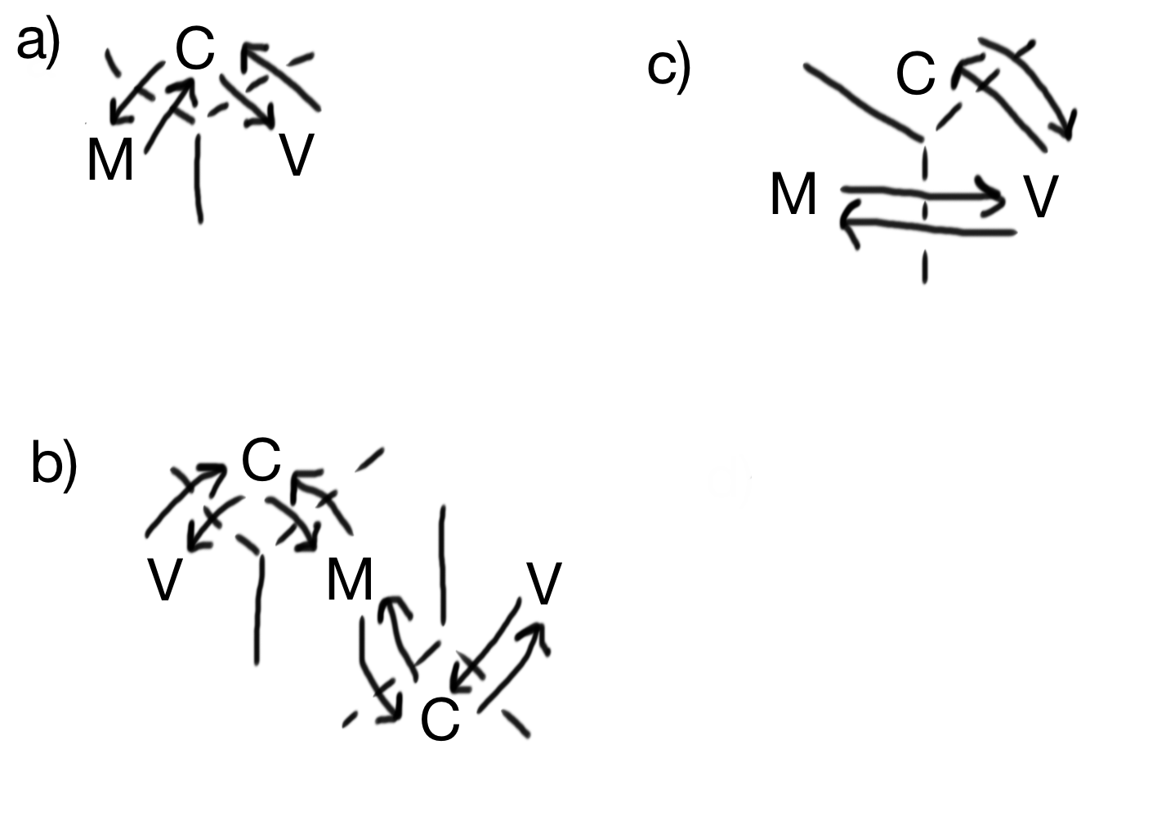

**Answer:** C

**Part B**

Q8. Create an application that will have three screens, On first screen you will have two button named “Present” and “Push”. When you click "Present" it should present a new VC and when you click "Push", it should navigate to a new screen. Make sure you should be able to come to first screen from pushed and presented view controllers. [20]

Q9. One struct and a class is written, out of 4 options provided choose the correct answer and write the reason for correct answer.[20]

struct Person {

var name: String

var age: Int

}

class Person1 {

var name: String

var age: Int

}

a) let p1 = Person()

let p2 = Person1()

b) let p1 = Person(“RJT test”, 25)

let p2 = Person1()

c) let p1 = Person(name: “RJT test”, age: 25)

let p2 = Person1() //this line will gives error due no initializer inside the class

d) let p1 = Person(name: “RJT test”, age: 25)

let p2 = Person1(name: “RJT test1”, age: 25).

**Answer:** C

**Reason:** There is no init() method inside the class declaration, and the variables name and age are also not initialized.

Q10. Build an iOS app that is able to send information from one viewcontroller to another viewcontroller using segues. When a button is clicked on the first view controller, a segue should be initiated and the first view controller should send the current date to the next view controller. The second view controller should display this date in a label. [20]

Q->11 Write code to show difference between guard let, if let , guard else.[10]